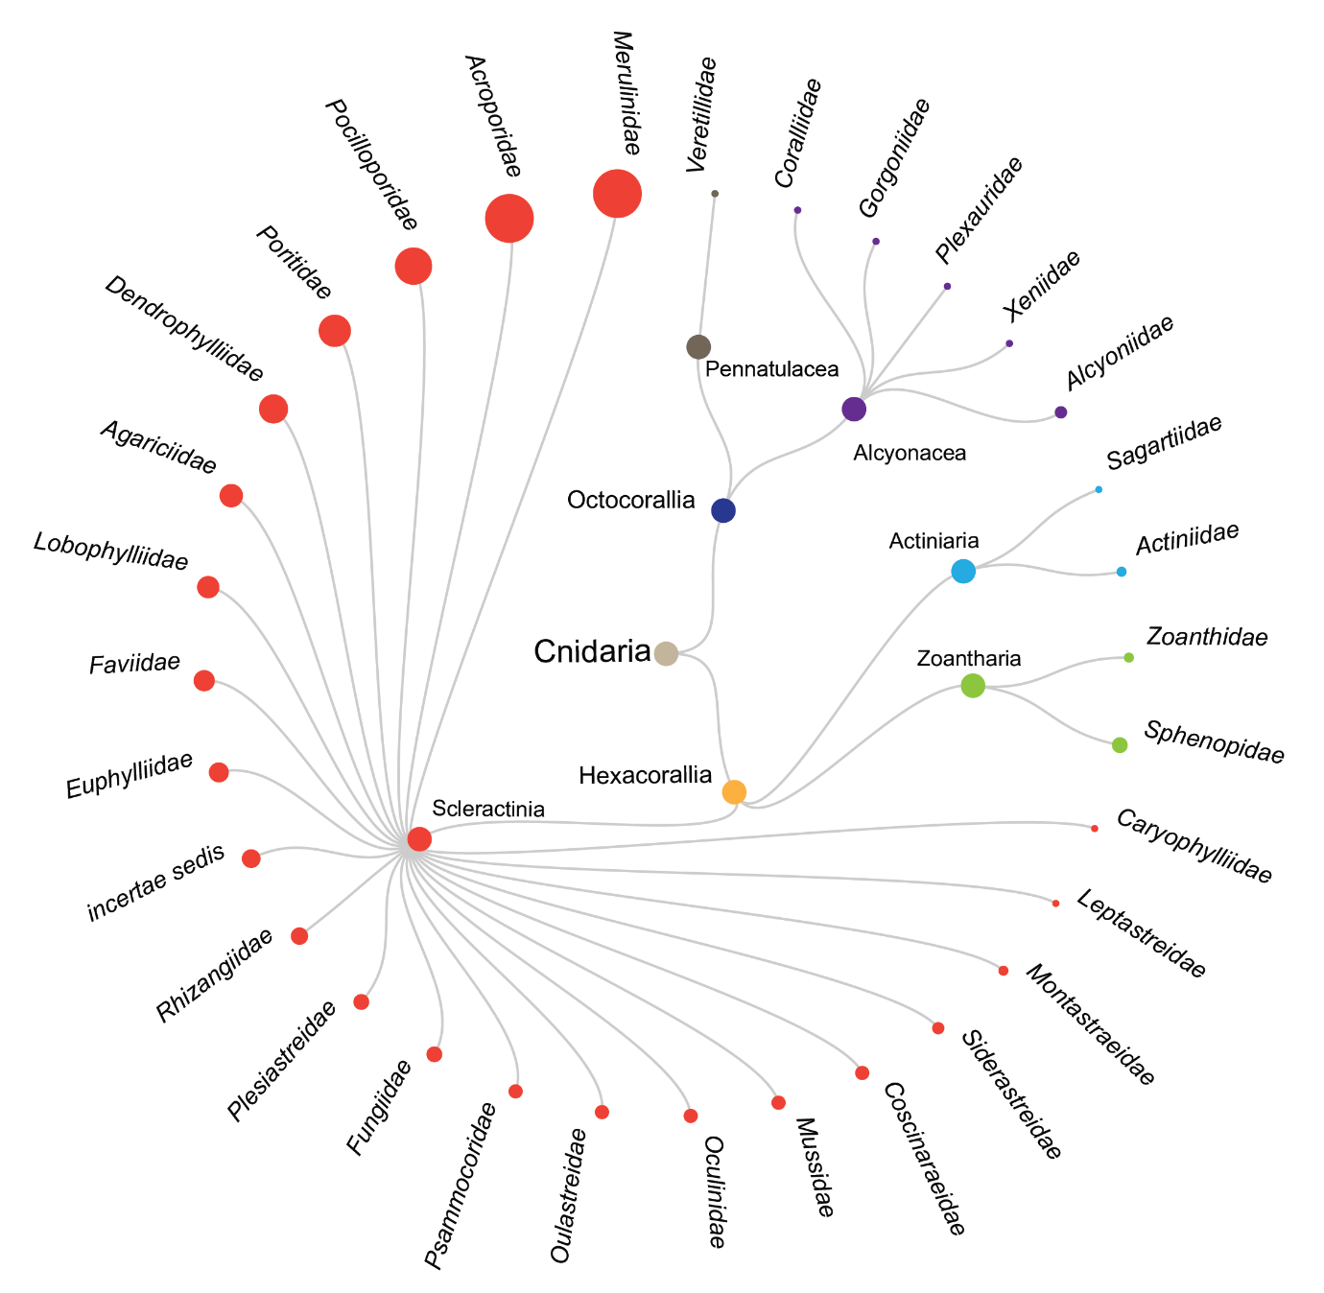

Figure 13 Dendrogram showing the classes and families studied by the literature recorded in this systematic map.